Table of Contents
1. First Time Enablement 2
1.1 Register Vault Application in Entra Admin Center 2
1.2 Create SharePoint Site and Enable Collaborative Authoring with PowerShell 3
1.3 SharePoint Site Hardening – Option 1 – in SharePoint 3
1.4 SharePoint Site Hardening - Option 2 - with PowerShell 4
1.5 Authorize Connection between Vault and Office 365 5
2. Enablement in Additional Vault(s) 6
2.1 Add Redirect URI(s) to the App Registration 6
2.2 Authorize Connection between Vault and Office 365 6
3. Re-enablement after a Vault Refresh 7
3.1 Re-authorize the Connection between Vault and Office 365 7
4. External User Setup 8
4.1 Grant Application Registration Permissions for Automated Guest Invitations (Optional) 8
4.2 Enable External Collaboration at the SharePoint Tenant Level 8
4.3 Enable External Collaboration at the Root & Site Collection Level 8
4.4 Invite External Users to Azure (Optional) 9
4.5 Add User(s) to Vault 9
5. Security Token Renewal 9
5.1 Generate New Security Token in Entra 10
5.2 Re-authorize Connection between Vault and Office 365 10
6. Powershell Script Variables 10

First Time Enablement

Register Vault Application in Entra Admin Center
Step | Completed | Comments
Navigate to Vault Admin > Settings > Checkout Settings and click Edit
In a separate window, login as Admin to Entra Admin Center
Click on App Registrations
Click on New Registration
Give it a name and enter a redirect URI
(format must be
https://Your Vault DNS/ui/clientTiles/office365/oauth2)
Click Register
Copy and paste the newly created Directory (tenant) ID and Application (client) ID from Entra into Vault Checkout Settings |  | Directory (tenant) ID:  _____________________  Application (client) ID:  _____________________
From the Entra app page, click API permissions
Click Add a permission
Click Microsoft Graph and then Application Permissions
Under Sites section, check off:
- Sites.Selected
Under Users section, check off:
- User.ReadBasic.All*
Under Users section, check off:
- User.Invite.All **
Under Directory section, check off:
- Directory.ReadWrite.All **

*This permission is required if using collaborative authoring workflow actions
**These permissions are for the optional Auto Invite External Users feature
Click Add permissions
Click Grant admin consent for <Tenant Name>
From the Entra app page, click Certificates & secrets
Click New client secret
Add a description and pick the longest acceptable expiration period (recommended – Never)
Click Add
Copy and paste your newly created Secret Value from Azure into Vault Checkout Settings |  | Secret Value:  _____________________

Create SharePoint Site and Enable Collaborative Authoring with PowerShell
Step | Completed | Comments
Install PowerShell (at least version 7)
Open PowerShell and install PnP PowerShell Module with the following command:

Install-Module PnP.PowerShell -RequiredVersion 2.12
Download and open the PowerShell scripts provided in Vault Help
Prepare the variables in the SitePnP.ps1 script. Each variable must be in a quote. Example: $alias = "Alias"

$adminUrl = “The URL of the SharePoint Admin Center”
$siteBaseUrl = “The base URL for SharePoint sites in the tenant”
$siteTitle = “The title of the new SharePoint site”
$owner = “The email address of the site owner”
$alias = “The unique alias for the SharePoint site”
$tenantUrl = “The tenant domain name used for Entra app registrations”
$appId = “The App ID of the Entra App created in 1.1”
$displayName = “The name of the Azure App created in 1.1”
$siteUrl = “The full URL of the SharePoint site constructed using $siteBaseUrl + $alias”
$entraIDApp = “ID of the Azure Admin App that grants Collaborative Authoring Azure App access to the SharePoint site. If left blank, it will be dynamically created upon running this script”.
$adminAppName = "Veeva CA Admin App"

Important: See Powershell Script Variables for more information on how to set and use these variables.
Go the folder where you saved the PowerShell script.
Run the ‘SitePnP.ps1’ script in PowerShell command prompt as follows. If you have updated the name and the new name includes spaces or special characters, it is recommended to specify the entire file name within double quotes to avoid any issues with spaces & characters in the file name.

.\SitePnP.ps1
Navigate to the newly Created SharePoint site’s Documents Library
Copy and paste the URL from SharePoint into Vault Checkout Settings |  | URL:  _____________________

SharePoint Site Hardening – Option 1 – in SharePoint
Step | Completed | Comments
Login to SharePoint as the administrator user who created the site in 1.2
Navigate to the site created in 1.2
From the site Settings, click Site permissions
Click Change how members can share
Select Only site owners can share files, folders, and the site and disable Allow access requests
Click Save
Verify that the Site Owner group only includes the administrator who created the site in 1.2
Select Advanced Site Permissions
Select Permission Levels
Select Contribute Permission Level
Disable the Delete Items list permission
Click Submit
Click Documents
Open Settings
Click Library Settings
Click Permissions for this document library
Select Site Members and Site Visitors, click Remove User Permissions, and confirm the prompt
Return to the Documents library
Copy and paste the URL from SharePoint into Vault Checkout Settings

SharePoint Site Hardening - Option 2 - with PowerShell
Step | Completed | Comments
Download SharePoint Online Client Components SDK from Microsoft’s Download Center
Open PowerShell and install PnP PowerShell Module with the following command:

Install-Module -Name Microsoft.Online.SharePoint.PowerShell
Prepare the variables in the SiteHardening.ps1 script

$siteTitle = “The title of the new SharePoint site”
$siteUrl = “The full URL of the SharePoint site constructed using $siteBaseUrl + $alias”

Run the SiteHardening .ps1 script in SharePoint Online Management Shell

.\ sitehardening.ps1

Authorize Connection between Vault and Office 365
Step | Completed | Comments
Within Vault Checkout Settings, click Authorize
Once your Integration Status is verified within Vault Checkout Settings, click Save

Enablement in Additional Vault(s)

Add Redirect URI(s) to the App Registration
Step | Completed | Comments
Login as Admin to Entra Admin Center
Click on App Registrations
Find the App Registration initially created for Collaborative Authoring in 1.1
From the Entra app page, click Authentication
Click Add a platform
Select Web as the application type
Enter a Redirect URI (format must be
https://Your Vault DNS/ui/clientTiles/office365/oauth2)
Click Configure

Authorize Connection between Vault and Office 365
Step | Completed | Comments
Navigate to Vault Admin > Settings > Checkout Settings and click Edit
Copy and paste the Directory (tenant) ID and Application (client) ID from 1.1 into Vault Checkout Settings
Copy and paste your Secret Value from 1.1 into Vault Checkout Settings
Copy and paste the URL from 2 into Vault Checkout Settings
Click Authorize
Once your Integration Status is verified within Vault Checkout Settings, click Save

Re-enablement after a Vault Refresh

Re-authorize the Connection between Vault and Office 365
Step | Completed | Comments
Navigate to Vault Admin > Settings > Checkout Settings and click Edit
Copy and paste the Directory (tenant) ID and Application (client) ID from 1.1 into Vault Checkout Settings
Copy and paste your Secret Value from 1.1 into Vault Checkout Settings
Copy and paste the URL from 1.2 into Vault Checkout Settings
Click Authorize
Once your Integration Status is verified within Vault Checkout Settings, click Save

External User Setup
External users are collaborators with email addresses from different domains. When using Collaborative Authoring with external users, you can enable automatic invitations through Azure in your Vault. Once automatic invitations are enabled, Vault will send external users an email invitation when they click Edit, automatically adding them to the session.

Grant Application Registration Permissions for Automated Guest Invitations (Optional)
Step | Completed | Comments
Login as Admin to Entra Admin Center
Click on App Registrations
Find the App Registration initially created for Collaborative Authoring in 1.1
From the Entra app page, click View API permissions
Click Add a permission
Click Microsoft Graph and then Application Permissions
Under Sites section, check off:
- Sites.Selected
Under Users section, check off:
- User.Invite.All **
Under Directory section, check off:
- Directory.ReadWrite.All **

**These permissions are for the optional Auto Invite External Users feature
Click Add permissions

Enable External Collaboration at the SharePoint Tenant Level
Step | Completed | Comments
Login to the Office365 Admin Center
Navigate to SharePoint Admin
Under Policies, Click Sharing
Within the External sharing > Content can be shared with: section, allow for sharing with external users by making a selection other than Only people in your organization

Enable External Collaboration at the Root & Site Collection Level
Step | Completed | Comments
Click Sites
Click Active Sites
Locate Root site
(ex. Site name: Company Team Site
URL: company.sharepoint.com)
Click on Site Name
Click on the Policies tab
Click Edit under External Sharing
Within the External sharing > Site content can be shared with: section, allow for sharing with external users by making a selection other than Only people in your organization
Click Save
Click Active Sites
Locate the site that you created in 1.2
Click on the Policies tab
Click Edit under External Sharing
Within the External sharing > Site content can be shared with: section, allow for sharing with external users (recommended – Existing guests only)
Click Save

Invite External Users to Azure (Optional)
Skip this step if you are not using Vault to Automate Invites.
Step | Completed | Comments
Navigate to your Entra Admin Center
Click Users
Click New Guest User
Ensure Invite User is selected and enter guest user information
Click Invite

Add User(s) to Vault
Step | Completed | Comments
Navigate to Vault Admin > Users & Groups
Click Create
Add user details and ensure that the user’s email address exactly matches the email in Entra
Click Save

Security Token Renewal
Security tokens created in Azure are typically assigned an expiration date. The steps below outline the process whereby new tokens can be generated for the integration. This step can be completed prior to the secret expiring minimizing any disruption on checkout documents.

Generate New Security Token in Entra
Step | Completed | Comments
Navigate to Vault Admin > Settings > Checkout Settings and click Edit
In a separate window, login as Admin to Entra Admin Center
Click on App Registrations
Find the App Registration initially created for Collaborative Authoring in 1.1
From the Azure app page, click Certificates & secrets
Click New client secret
Add a description and pick the longest acceptable expiration period (recommended – Never)
Click Add
Copy and paste your newly created Secret Value from Azure into Vault Checkout Settings |  | Secret Value:  _____________________

Re-authorize Connection between Vault and Office 365
Step | Completed | Comments
Within Vault Checkout Settings, click Authorize
Once your Integration Status is verified within Vault Checkout Settings, click Save

For more information on Collaborative Authoring, visit Vault Help & Collaborative Authoring Resource Hub.

Powershell Script Variables
$adminUrl = "https://test-admin.sharepoint.com"
You can get this URL by navigating to your SharePoint Admin center, and copying the first part of the URL there:
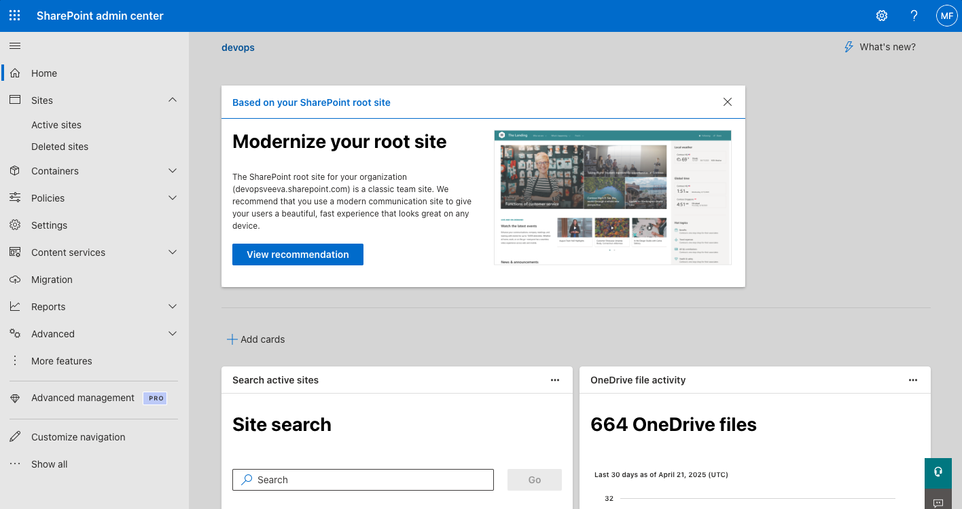
$siteBaseUrl = "https://test.sharepoint.com/sites/"
You can get this URL by navigating to any existing SharePoint site and the URL will be up through “/sites/”:
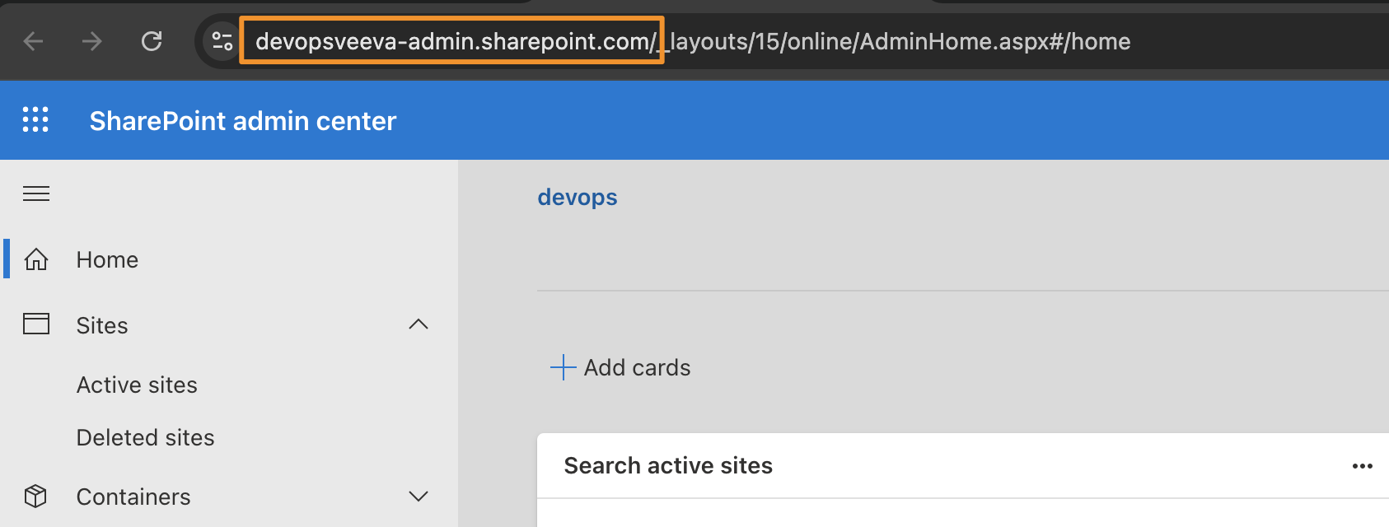
Note: it is important that it end with a forward slash
$siteTitle = "Site Title"
This can be defined however is preferred, i.e. “Vault Collaboration”
$owner = "owner@domain.com"
This would be the Microsoft username for the administrator who is running the script (i.e. “michaelferrell@devopsveeva.onmicrosoft.com”)
$tenantUrl = "domain.com"
You can get this URL by navigating to the Microsoft Entra Admin Center, and the Overview tab. The URL needed is the Primary Domain field:
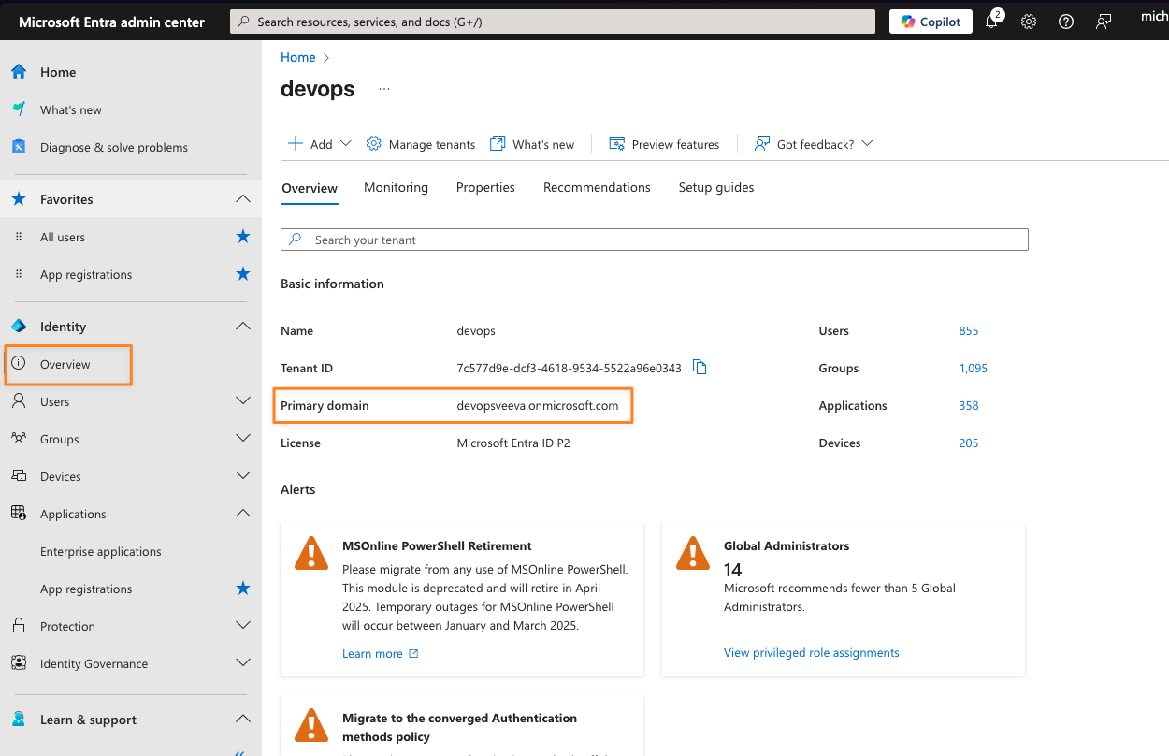
$appId = "appId"
This is the Application (client) ID for the app registration for your Vaults:
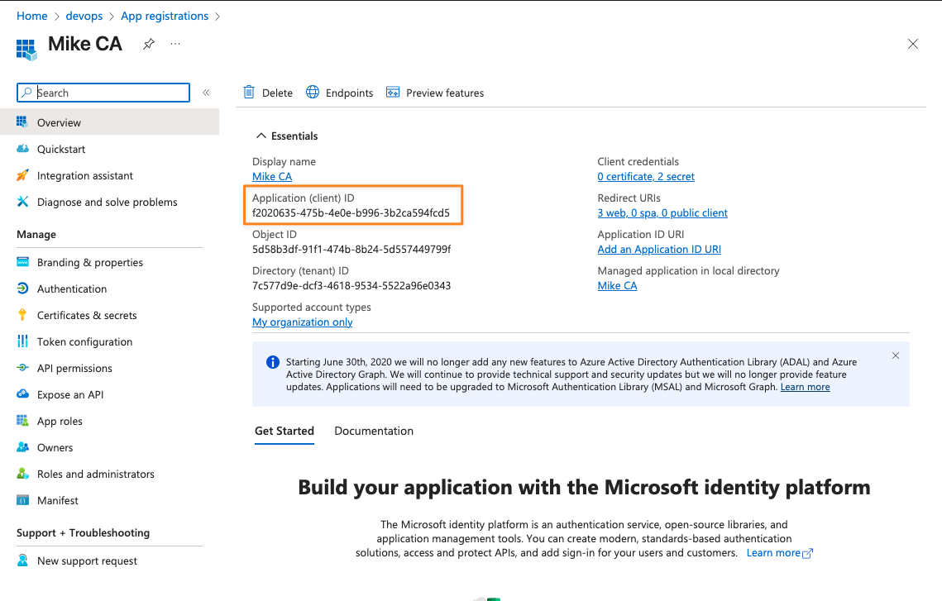
$displayName = "Display Name"
This is the Display Name for the app registration for your Vaults:
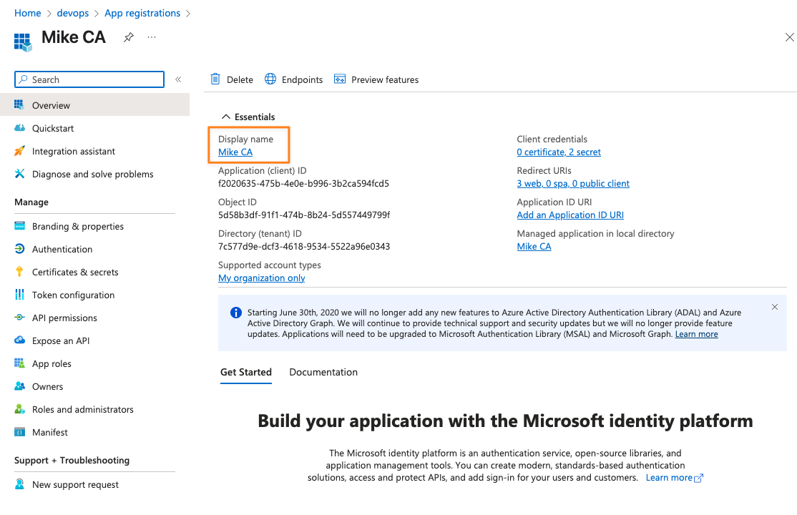
$siteUrl = “https://test.sharepoint.com/sites/siteAlias”
If you are setting up a net new site, nothing is needed for this variable (the script will create this using $siteBaseUrl and $alias. If you’re updating an existing site:
This is the URL for your existing SharePoint site, which you can get by navigating to the site in the SharePoint Admin center and copying the Site Address:
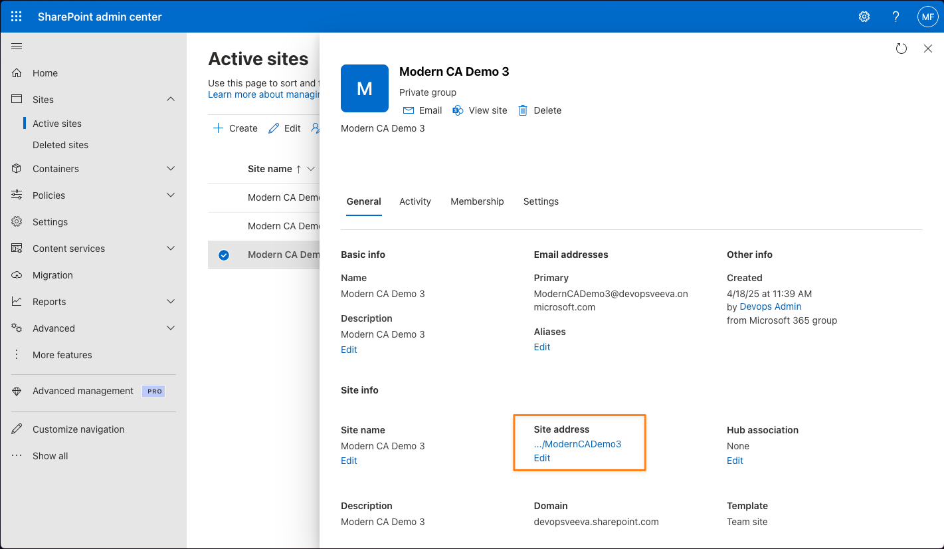
$adminAppName = "Admin App Name"
The script will create a Entra Admin ID App with the name you specify in this variable. This new app will get ‘AllSites.FullControl’ permission, and you can give this app any name that you prefer. This site permission is needed to grant your existing application permission to manage your SharePoint site (without a Service Account).
The first time you run the script, this variable should be used and the $entraIDApp variable should be commented out. For subsequent uses of the script, the newly created Entra Admin ID app can be used to configure Collaborative Authoring in other Vault environments in your organization. Record the app Id for future use and comment this variable out if you are planning to run this script again for other Vault environments.
This admin app is required to update permissions, but once all updates are made to existing app registrations and SharePoint sites, this app can be deleted.
$entraIDApp = "entraIdApp"
If you already have an Entra Admin app created using the above variable $adminAppName (that has the AllSites.FullControl permission), then comment out the variable $adminAppName and enter the Application (client) ID for that Entra Admin ID app here, rather than using $adminAppName to create a new Entra Admin App again.

